Cairo University Faculty of Computers and Information



**Software Engineering II**

**Software design specification document**

**2020**

**Project Team**

|  |  |  |
| --- | --- | --- |
| **ID** | **Name** | **Email** |
| 20170197 | Karim Magdy | kareemmagdy1@yahoo.com |
| 20170336 | Youssef Ismail Okasha | yousefokasha61@gmail.com |
| 20170206 | Mark Samuel | mark@newtechservics.com |
| 20170188 | Amr Magdy | flawless146@yahoo.com |
|  |  |  |
|  |  |  |

**TA: Mahmoud hadad**

Contents

Class diagram design 2

Sequence diagram design 3

Github repository link 5

# Class diagram design

# Screenshot (68)

# Sequence diagram design

1. Register

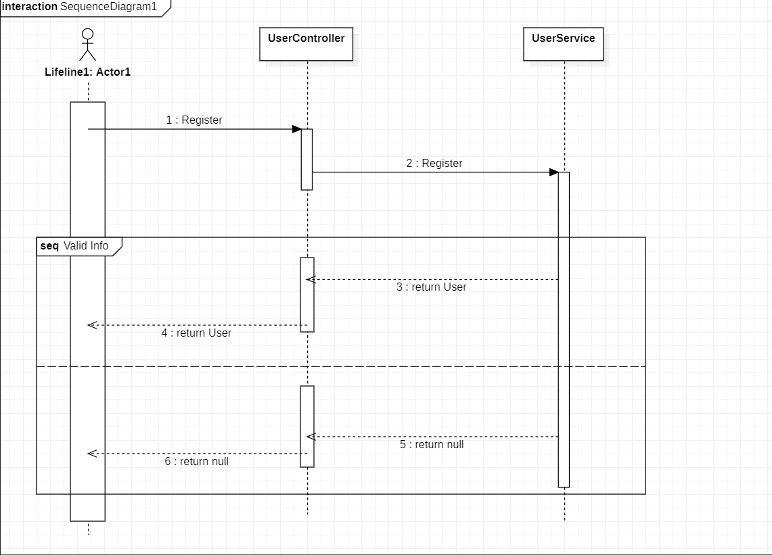

1. getAllRegisteredUsers

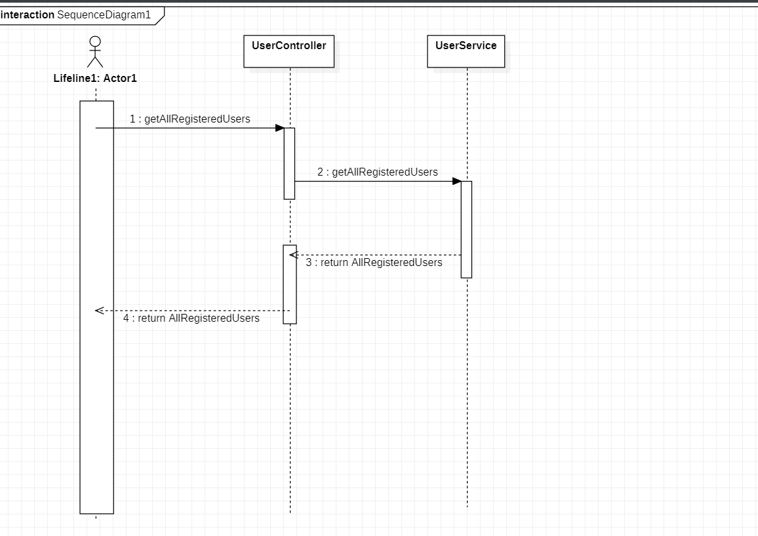

**Proposed Architecture**: MVC

# Github repository link:

<https://github.com/yousefokasha61/E-commerce>